SOUTH DEVON GARDEN RAILWAY GROUP
EXETER GARDEN RAILWAY SHOW 28TH OCTOBER 2023
http://www.exetergardenrailwayshow.com/bringandbuy.htm
2023 BRING AND BUY STAND

Name: |  | Contact Telephone Number:
Address:
Post Code:
I am happy to accept cheque/s in payment for sold items YES / NO (please circle one)
Description of item being offered for sale |  |  | Lot | Price |  | Sold Value or Returned
 |  |  | 1
 |  |  | 2
 |  |  | 3
 |  |  | 4
 |  |  | 5
 |  |  | 6
 |  |  | 7
 |  |  | 8
 |  |  | 9
 |  |  | 10
 |  |  | 11
 |  |  | 12
 |  |  | 13
 |  |  | 14
Space for more items overleaf. Total this page:
Notes for completion of this form:

Sellers will be allocated a Reference Number on ‘booking in‘ which will be written on this form and on your tie-on labels.
To save time, securely attach a standard size, tie-on, parcel label to each one of your ‘for sale’ items prior to the show. Each label must clearly show the Lot Number, the price, and brief details of the item offered for sale. Stickers will not be accepted. An example of an acceptable label is shown at the end of this form. Several items may be grouped together to form a lot, but these must be secured to each other or securely bagged. PLEASE REFER TO OUR WEB SITE FOR “BOOKING IN” CLOSING TIMES

Please Note: It is a condition in accepting the above items for sale that you have read and agreed the conditions of acceptance and sale below.

CONDITIONS OF ACCEPTANCE AND SALE
- ALL ITEMS DISPLAYED, HANDLED & OFFERED FOR SALE ARE DONE SO ENTIRELY AT THE OWNER'S RISK.
- THE SOUTH DEVON GARDEN RAILWAY GROUP DOES NOT ACCEPT ANY LIABILITY FOR THE CONDITION OF ITEMS SOLD NOR ANY FINANCIAL LOSSES THAT MAY BE INCURRED BY ANY PARTY WHATSOEVER.
- NO OFFERS AGAINST AN ASKING PRICE WILL BE ACCEPTED WITHOUT REFERENCE TO THE OWNER.
- OWNERS WISHING TO ALTER AN ASKING PRICE DURING THE SHOW MAY DO SO BY SPEAKING TO A
MEMBER OF THE SALES STAFF.
- ALL ITEMS SOLD ARE SUBJECT TO A 12.5% COMMISSION DEDUCTED IMMEDIATLY UPON THE SALE OF ANY ITEM.
- PLEASE REMEMBER THE STAFF WILL BE VERY BUSY DURING THE SHOW AND MAY NOT BE ABLE TO ACCOMODATE ALL REQUESTS.
- THE BRING AND BUY STALL COORDINATOR’S DECISION IS FINAL.

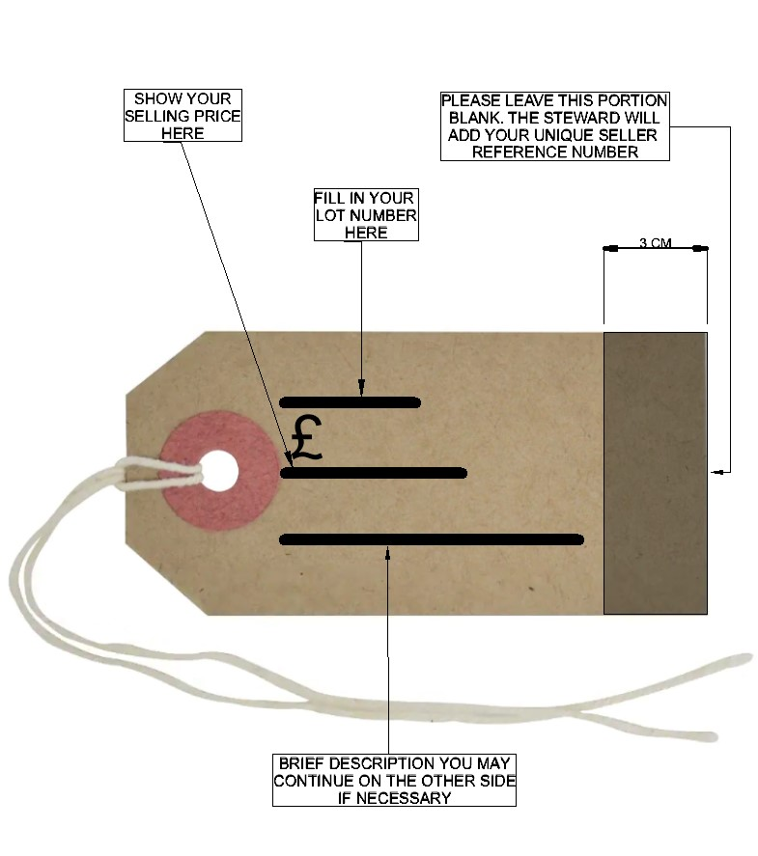
Description of item being offered for sale | Lot | Price | Sold Value or Returned
 | 15
 | 16
 | 17
 | 18
 | 19
 | 20
 | 21
 | 22
 | 23
 | 24
 | 25
 | 26
 | 27
 | 28
 | 29
 | 30
Total for this page:
Total from overleaf:
Total from other sheets:
Total value of sales:
Less 12.5% commission:
Net Amount Due:

I acknowledge receipt of the returned items marked “R”, and agree the total value of sales and amount due to me.

Name: ……………………………………….

Signature: …………………………………….

